EXP NO – 1.3

**NAME RAJDEEP JAISWAL UID – 20BCS2761**

**BRANCH – B.TECH (CSE) SEC/GROUP – 26(B)**

**SEMESTER – 2ND D.O.P – 3 MAY 2021**

**SUBJECT – COMPUTER WORKSHOP**

TOPIC OF EXPERIMENT

**There are three planes A,B and C. Plane will take off on every pth day i.e. p, p2, p3 and so on. Plane B will takeoff on every qth day and plane C will takeoff on every rth day. There is only one runway and the takeoff timing is same for each of the three planes on each day. Your task is to find out the maximum number of flights that will successfully takeoff in the period of N days.**

**Note: If there is collision between the flights no flight will take off on that day.**

**SOL:**

There are three planes A, B and C. Plane A will takeoff on every pth day i.e. p, 2p, 3p and so on. Plane B will takeoff on every qth day and plane C will takeoff on every rth day. There is only one runway and the takeoff timing is same for each of the three planes on each day. Your task is to find out the maximum number of flights that will successfully takeoff in the period of N days.

**Note:**If there is collision between the flights no flight will take off on that day.

**Input Format**  
The first line of the input contains a single integer T, the number of test cases.  
Then T lines follow each containing four space-separated integers N, p, q and r as denoted in the statement.

**Output Format**  
For each test case print a single integer representing the maximum number of flights that will successfully takeoff in the period of N days.

**Constraints**  
1≤T≤10  
1<N,p,q,r < 10^5

**Sample Input**

**2**

**10 2 3 4**

**10 2 2 4**

**Sample Output**

**4**

**0**

**CODE IN TEXT FORM:**

#include <bits/stdc++.h>

using namespace std;

int f[100000];

int main()

{

int t; cin>>t; while(t--)

{

int n, p, q, r;

cin >> n >> p >> q >> r;

memset(f, 0, sizeof f);

for(int i = p; i <= n; i += p)

f[i] ++;

for(int i = q; i <= n; i += q)

f[i] ++;

for(int i = r; i <= n; i += r)

f[i] ++;

int cnt = 0;

for(int i = 1; i <= n; i ++)

if(f[i] == 1)

cnt ++;

cout << cnt << '\n';

}

}

**CODE IN COMPILER**

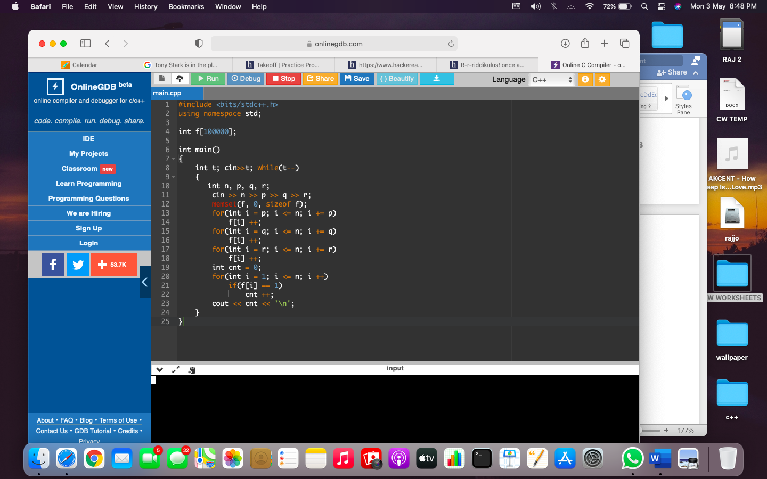

**OUTPUT :**

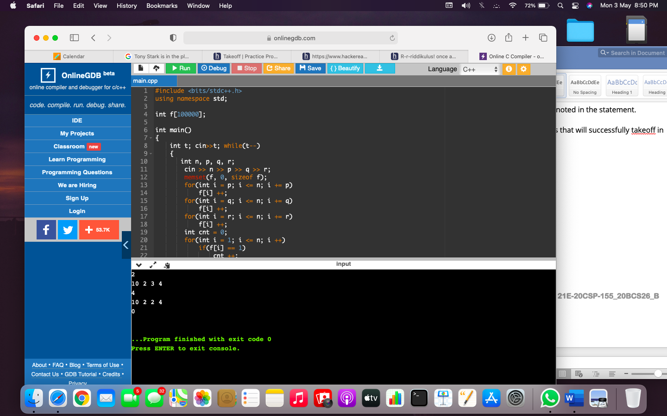

LEARNING OUTCOMES

1. Apply coding skills to solve application based problems on competitive platforms such as Hacker Rank/ Hacker Earth/Code Chef.
2. Understand the basic concept and structure of computer hardware
3. Identify the existing configuration of the computers and peripherals.
4. Installing and uninstalling multiple operating systems on a machine.
5. Apply their knowledge about computer peripherals to identify /rectify problems on-board.

EVALUATION COLUMN (To be filled by concerned faculty only)

|  |  |  |  |
| --- | --- | --- | --- |
| **Sr. No.** | **Parameters** | **Maximum**  **Marks** | **Marks**  **Obtained** |
| 1. | Worksheet Completion including writing learning objective/ Outcome | 10 |  |
| 2. | Post Lab Quiz Result | 5 |  |
| 3. | Student engagement in Simulation/ Performance/ Pre Lab Questions | 5 |  |
| 4. | Total Marks | 20 |  |